**Game studio management system**



**Session 2023 – 2027**

**Submitted by:**

Muhammad Omer (2023 – CS - 68)

**Supervised by:**

Miss Maida

Course: CSC-102 Programming Fundamentals

Department of Computer Science

**University of Engineering and Technology**

**Lahore Pakistan**

Short Description of your project

I want to create a game studio management system. It can be used to manage a game studio. You can use it to give tasks to your employees and the employees can use it to keep track of their deadlines and workload

Users of Application:

The program will have three users:

1. Admin
2. Programmer
3. Game Artist

Functional Requirements:

|  |  |
| --- | --- |
| **User** | **task** |
| Admin | Add tasks |
| Admin | Remove tasks |
| Admin | Preview task completion |
| Admin | View employee attendance |
| Artist | Clock in |
| Artist | Clock out |
| Artist | View given tasks |
| Artist | Mark task as done |
| Programmer | Clock in |
| Programmer | Clock out |
| Programmer | View given tasks |
| Programmer | Mark task as done |

WireFrames:

Login screen:

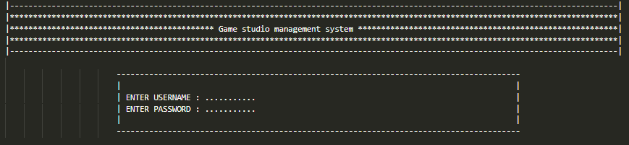

Admin screen:

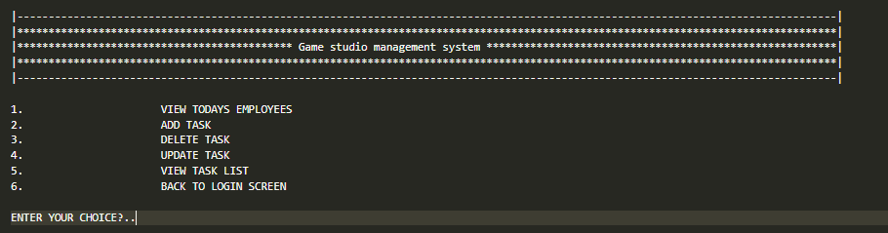

Employee screen

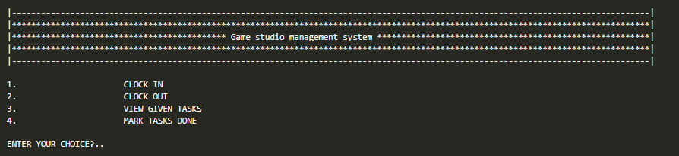

**Function Prototypes**

//general use functions

*int* ascii_to_int(string *x*);

string get_string_input();

*void* gotoxy(*int* *x*, *int* *y*);

//program functions

*void* ready(string *x*[],string *y*[],string *z*[],string *employee_id*,*bool* *taskdone_pr*[], string *tasklist_pr*[]);

*void* printHeader();

//login functions

*void* loginMenu(string *username_database*[],string *password_database*[],string *user_perm*[],string *employee_id*);

string loginInput(string *username_database*[],string *password_database*[],string *user_perm*[],string *employee_id*);

string sign_in(string *x*[],string *y*[],string *z*[],string *employee_id*);

*void* sign_up(string *x*[],string *y*[],string *z*[],string *employee_id*);

*void*invalid_creditionals(string*username_database*[],string *password_database*[],string *user_perm*[],string *employee_id*);

//user front page

*void* admin_page(*int* *task_num*,*bool* *taskdone_pr*[20],string *tasklist_pr*[20],*int* *taskid_pr*);

*void* employee_page(*int* *task_num*,*bool* *taskdone_pr*[20],string *tasklist_pr*[20],*int* *taskid_pr*);

//tasklist

*void* add_tasks(*int* *task_num*,*bool* *taskdone_pr*[20],string *tasklist_pr*[20],*int* *taskid_pr*);

*void* view_task(*int* *task_num*,*bool* *taskdone_pr*[20],string *tasklist_pr*[20],*int* *taskid_pr*);

//validation functions

*void* validation_fail();

*bool* login_Input_validation(string *option*);

*bool* sign_up_validation(string *option*);

**Functions Working Flow**

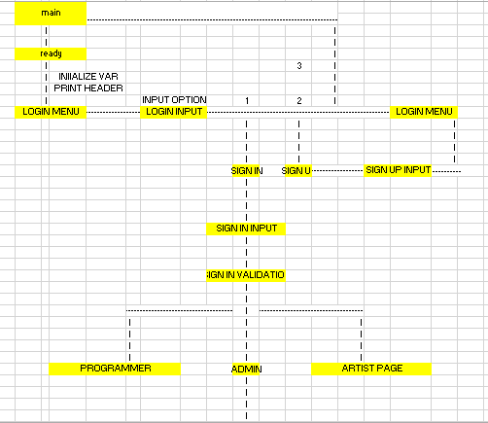

**Complete Code of the Business Application**

#include <iostream>

#include <conio.h>

#include <windows.h>

#include <string>

using *namespace* std;

//gobal variables

string state;

//general use functions

*int* ascii_to_int(string *x*);

string get_string_input();

*void* gotoxy(*int* *x*, *int* *y*);

//program functions

*void* ready(string *x*[],string *y*[],string *z*[],string *employee_id*,*bool* *taskdone_pr*[], string *tasklist_pr*[]);

*void* printHeader();

//login functions

*void* loginMenu(string *username_database*[],string *password_database*[],string *user_perm*[],string *employee_id*);

string loginInput(string *username_database*[],string *password_database*[],string *user_perm*[],string *employee_id*);

string sign_in(string *x*[],string *y*[],string *z*[],string *employee_id*);

*void* sign_up(string *x*[],string *y*[],string *z*[],string *employee_id*);

*void* invalid_creditionals(string *username_database*[],string *password_database*[],string *user_perm*[],string *employee_id*);

//user front page

*void* admin_page(*int* *task_num*,*bool* *taskdone_pr*[20],string *tasklist_pr*[20],*int* *taskid_pr*);

*void* employee_page(*int* *task_num*,*bool* *taskdone_pr*[20],string *tasklist_pr*[20],*int* *taskid_pr*);

//tasklist

*void* add_tasks(*int* *task_num*,*bool* *taskdone_pr*[20],string *tasklist_pr*[20],*int* *taskid_pr*);

*void* view_task(*int* *task_num*,*bool* *taskdone_pr*[20],string *tasklist_pr*[20],*int* *taskid_pr*);

*void* mark_task_done(*int* *task_num*, *bool* *taskdone_pr*[20], string *tasklist_pr*[20], *int* *taskid_pr*);

//validation functions

*void* validation_fail();

*bool* login_Input_validation(string *option*);

*bool* sign_up_validation(string *option*);

*int* main()

{

    system ( "cls" );

    printHeader();

    cout << endl;

    cout <<"press any key to continue :-";

    getch ();

    //sign in creditionals

    string employee_id;

    string username_database[10];

    string password_database[10];

    string user_perm[10];

    //tasklist var

*int* task_num = 0 ;

*bool* taskdone_pr[20];

    string tasklist_pr[20];

*int* taskid_pr = 0;

    ready(username_database,password_database,user_perm,employee_id, taskdone_pr, tasklist_pr);     //calling ready to initialize variables

    loginMenu(username_database,password_database,user_perm,employee_id);             //login menu redirects to required login menu

    if (state == "admin")

    {

        admin_page(task_num,taskdone_pr,tasklist_pr,taskid_pr);

    }

    else if (state == "employee")

    {

        employee_page(task_num,taskdone_pr,tasklist_pr,taskid_pr);

    }

}

//general use functions

*int* ascii_to_int(string *convert_to_int*)

{

    string temp_string;

*int* temp_int;

    temp_string = *convert_to_int*;

    temp_int = stoi(temp_string);

    return temp_int;

}

string get_string_input()

{

    string temp_string;

    cin.ignore();

    getline(cin,temp_string);

    return temp_string;

}

*void* gotoxy(*int* *x*, *int* *y*)

{

  static HANDLE h = NULL;

  if(!h)

    h = GetStdHandle(STD_OUTPUT_HANDLE);

  COORD c = { *x*, *y* };

  SetConsoleCursorPosition(h,c);

}

//headers

*void* printHeader()

{

cout << "|-----------------------------------------------------------------------------------------------------------------------------------|" <<endl;

cout << "|***********************************************************************************************************************************|" <<endl;

cout << "|******************************************** Game studio management system ********************************************************|" <<endl;

cout << "|***********************************************************************************************************************************|" <<endl;

cout << "|-----------------------------------------------------------------------------------------------------------------------------------|" <<endl;

}

//ready

*void* ready(string *username_database*[],string *password_database*[],string *user_perm*[],string *employee_id*,*bool* *taskdone_pr*[],string *tasklist_pr*[])

{

    for (*int* x =0 ;x < 10 ;x++)

    {

*username_database*[x] = "0";

*password_database*[x] = "0";

    }

    for (*int* x =0 ;x < 20 ;x++)

    {

*taskdone_pr*[x] = false;

    }

*int* x=0;

    for(*int* x =1;x<=20;x++)

    {

*taskdone_pr*[x] = false;

    }

*tasklist_pr*[1] = "program";

*tasklist_pr*[2] = "draw";

*tasklist_pr*[3] = "manage";

*username_database*[0] = "admin";

*password_database*[0] = "admin";

*user_perm*[0] = "admin";

*employee_id* = "0";

    system ( "cls" );

}

//login functions

*void* loginMenu(string *username_database*[],string *password_database*[],string *user_perm*[],string *employee_id*)

{

    string option;

    option = loginInput(*username_database*,*password_database*,*user_perm*,*employee_id*);

    if (option == "1")

    {

        sign_in(*username_database*,*password_database*,*user_perm*,*employee_id*);

    }

    else if (option =="2")

    {

        sign_up(*username_database*,*password_database*,*user_perm*,*employee_id*);

    }

    else if (option =="3")

    {

        main();

    }

    else

    {

        validation_fail();

        loginMenu(*username_database*,*password_database*,*user_perm*,*employee_id*);

    }

}

string loginInput(string *username_database*[],string *password_database*[],string *user_perm*[],string *employee_id*)

{

    string option;

    system ( "cls" );

    printHeader();

    std::cout << endl;

    std::cout << endl;

    std::cout << "1:) sign in"<<endl;

    std::cout << "2:) sign up"<<endl;

    std::cout << "3:) exit"<<endl;

    std::cout << endl;

    std::cout<< "Select option :-";

    cin >> option;

    if (login_Input_validation(option))

    {

        return option ;

    }

    else

    {

        validation_fail();

        loginMenu(*username_database*,*password_database*,*user_perm*,*employee_id*);

    }

}

string sign_in(string *username_database*[],string *password_database*[],string *user_perm*[],string *employee_id*)

{

    string entered_username,entered_password;

*int* entered_employee_id;

    string option;

    system ( "cls" );

    printHeader();

    cout << endl;

    cout << "ENTER EMPLOYEE ID :- ";

    cin >> *employee_id*;

    entered_employee_id = ascii_to_int(*employee_id*);

    cout << "ENTER USERNAME :- ";

    cin >> entered_username;

    cout << "ENTER PASSWORD :- ";

    cin >> entered_password;

    cout <<endl;

    cout << "press any key to continue";

    getch();

    if ((entered_username == *username_database*[entered_employee_id]) && (entered_password == *password_database*[entered_employee_id]))

    {

        if (*user_perm*[entered_employee_id]=="admin")

            state ="admin";

        if ((*user_perm*[entered_employee_id]=="programmar") || (*user_perm*[entered_employee_id]=="artist"))

            state="employee";

    }

    else

    {

        invalid_creditionals(*username_database*,*password_database*,*user_perm*,*employee_id*);

    }

}

*void* sign_up(string *username_database*[],string *password_database*[],string *user_perm*[],string *employee_id*)

{

*int* temp_int;                                                               //used to store conversion from ascii to int

    system ( "cls" );

    printHeader();

    cout << endl;

    cout << "ENTER EMPLOYEE ID :- ";

    cin >> *employee_id*;

    temp_int = ascii_to_int(*employee_id*);

    cout << "ENTER USERNAME :- ";

    cin >> *username_database*[temp_int];

    cout << "ENTER PASSWORD :- ";

    cin >> *password_database*[temp_int];

    cout << "admin , programmar or artist ? ";

    cin >> *user_perm*[temp_int];

    string option = *user_perm*[temp_int];

    if(sign_up_validation(option))

    {

        loginMenu(*username_database*,*password_database*,*user_perm*,*employee_id*);

    }

    else

    {

        validation_fail();

        sign_up(*username_database*,*password_database*,*user_perm*,*employee_id*);

    }

}

*void* invalid_creditionals(string *username_database*[],string *password_database*[],string *user_perm*[],string *employee_id*)

{

    string option;

    cout <<endl;

    cout <<"INVALID CREDITIONALS (press y to retry or press n to go back to login screen)";

    cin >> option;

    if (option == "y")

        sign_in(*username_database*,*password_database*,*user_perm*,*employee_id*);

    else if (option == "n")

        loginMenu(*username_database*,*password_database*,*user_perm*,*employee_id*);

    else

    {

        validation_fail();

        invalid_creditionals(*username_database*,*password_database*,*user_perm*,*employee_id*);

    }

}

*void* admin_page(*int* *task_num*,*bool* *taskdone_pr*[20],string *tasklist_pr*[20],*int* *taskid_pr*)

{

    system ( "cls" );

*char* option;

    cout<<"xxxxxxxxxxxxxxxxxxxxxxxxxxxxxxxxxxxxxxxxxxx||  A  D  M  I  N   P   A   G    E ||xxxxxxxxxxxxxxxxxxxxxxxxxxxxxxxxxxxxxxxxxxxxxxxxxxxxxxxxx"<<endl;

    cout<<"xxxxxxxxxxxxxxxxxxxxxxxxxxxxxxxxxxxxxxxxxxx|| For Adding tasks ------>Enter 1.||xxxxxxxxxxxxxxxxxxxxxxxxxxxxxxxxxxxxxxxxxxxxxxxxxxxxxxxxx"<<endl;

    cout<<"xxxxxxxxxxxxxxxxxxxxxxxxxxxxxxxxxxxxxxxxxxx|| For Task List    ------>Enter 2.||xxxxxxxxxxxxxxxxxxxxxxxxxxxxxxxxxxxxxxxxxxxxxxxxxxxxxxxxx"<<endl;

    cout<<"xxxxxxxxxxxxxxxxxxxxxxxxxxxxxxxxxxxxxxxxxxx|| Mark Task as Done ----->Enter 3.||xxxxxxxxxxxxxxxxxxxxxxxxxxxxxxxxxxxxxxxxxxxxxxxxxxxxxxxxx"<<endl;

    cout<<"xxxxxxxxxxxxxxxxxxxxxxxxxxxxxxxxxxxxxxxxxxx|| CHANGE USERS     ------>Enter 0.||xxxxxxxxxxxxxxxxxxxxxxxxxxxxxxxxxxxxxxxxxxxxxxxxxxxxxxxxx"<<endl;

    cin>> option;

    if (option =='0'||option =='1' ||option =='2'||option=='3')

    {

        if (option=='0')

        {

            main();

        }

        if (option=='1')

        {

            add_tasks(*task_num*,*taskdone_pr*,*tasklist_pr*,*taskid_pr*);

        }

        if(option=='2')

        {

            view_task(*task_num*,*taskdone_pr*,*tasklist_pr*,*taskid_pr*);

        }

        if(option=='3')

        {

            mark_task_done(*task_num*,*taskdone_pr*,*tasklist_pr*,*taskid_pr*);

        }

    }

    else

    {

        validation_fail();

        admin_page(*task_num*,*taskdone_pr*,*tasklist_pr*,*taskid_pr*);

    }

}

*void* employee_page(*int* *task_num*,*bool* *taskdone_pr*[20],string *tasklist_pr*[20],*int* *taskid_pr*)

{

 system ( "cls" );

*char* option;

    cout<<"xxxxxxxxxxxxxxxxxxxxxxxxxxxxxxxxxxxxxxxxxxx||  EMPLOYEE               PAGE    ||xxxxxxxxxxxxxxxxxxxxxxxxxxxxxxxxxxxxxxxxxxxxxxxxxxxxxxxxx"<<endl;

    cout<<"xxxxxxxxxxxxxxxxxxxxxxxxxxxxxxxxxxxxxxxxxxx|| For MARKING tasks ----->Enter 1.||xxxxxxxxxxxxxxxxxxxxxxxxxxxxxxxxxxxxxxxxxxxxxxxxxxxxxxxxx"<<endl;

    cout<<"xxxxxxxxxxxxxxxxxxxxxxxxxxxxxxxxxxxxxxxxxxx|| For Task List    ------>Enter 2.||xxxxxxxxxxxxxxxxxxxxxxxxxxxxxxxxxxxxxxxxxxxxxxxxxxxxxxxxx"<<endl;

    cout<<"xxxxxxxxxxxxxxxxxxxxxxxxxxxxxxxxxxxxxxxxxxx|| CHANGE USERS     ------>Enter 0.||xxxxxxxxxxxxxxxxxxxxxxxxxxxxxxxxxxxxxxxxxxxxxxxxxxxxxxxxx"<<endl;

    cin>> option;

    if (option =='0'||option =='1' ||option =='2')

    {

        if (option=='0')

        {

            main();

        }

        if (option=='1')

        {

            mark_task_done(*task_num*,*taskdone_pr*,*tasklist_pr*,*taskid_pr*);

        }

        if(option=='2')

        {

            view_task(*task_num*,*taskdone_pr*,*tasklist_pr*,*taskid_pr*);

        }

    }

    else

    {

        validation_fail();

        admin_page(*task_num*,*taskdone_pr*,*tasklist_pr*,*taskid_pr*);

    }

}

//tasklist functions

*void* add_tasks(*int* *task_num*,*bool* *taskdone_pr*[20],string *tasklist_pr*[20],*int* *taskid_pr*)

{

*char* option;

*bool* loop_cont = true;

    while(loop_cont)

    {

        cout << "ENTER TASK :- ";

*tasklist_pr*[*taskid_pr*]=get_string_input();

        cout << "ENTER ANOTHER TASK (y or n) ?";

        cin >> option;

        if (option =='y')

        {

            loop_cont = true;

*taskid_pr* = *taskid_pr* + 1 ;

        }

        else if (option =='n')

        {

            loop_cont = false;

*taskid_pr* = *taskid_pr* + 1 ;

        }

    }

    admin_page(*task_num*,*taskdone_pr*,*tasklist_pr*,*taskid_pr*);

}

*void* view_task(*int* *task_num*, *bool* *taskdone_pr*[20], string *tasklist_pr*[20], *int* *taskid_pr*)

{

*int* hei = 5;

    for (*int* i =0; i <*taskid_pr*; i++)

    {

        gotoxy(0, hei);

        cout << i+1 << ")- ";

        gotoxy(5, hei);

        cout << *tasklist_pr*[i];

        gotoxy(55, hei);

        if (*taskdone_pr*[i])

        {

            cout << "done";

        }

        else

        {

            cout << "not done";

        }

        cout << endl;

        hei = hei + 1;

    }

    getch();

    admin_page(*task_num*,*taskdone_pr*,*tasklist_pr*,*taskid_pr*);

}

*void* mark_task_done(*int* *task_num*, *bool* *taskdone_pr*[20], string *tasklist_pr*[20], *int* *taskid_pr*)

{

*int* hei = 5;

    for (*int* i =0; i <*taskid_pr*; i++)

    {

        gotoxy(0, hei);

        cout << i+1 << ")- ";

        gotoxy(5, hei);

        cout << *tasklist_pr*[i];

        gotoxy(55, hei);

        if (*taskdone_pr*[i])

        {

            cout << "done";

        }

        else

        {

            cout << "not done";

        }

        cout << endl;

        hei = hei + 1;

    }

    hei = hei + 1;

    gotoxy(0, hei);

*int* temp_int;

    cout <<"Enter task number to mark as done): ";

    cin>>temp_int;

    if (temp_int<= *taskid_pr* && temp_int > 0)

    {

*taskdone_pr*[temp_int-1] = true;

        cout << "Task " << *taskid_pr* << " marked as done." << endl;

    }

    else

    {

        validation_fail();

    }

        if (state == "admin")

    {

        admin_page(*task_num*,*taskdone_pr*,*tasklist_pr*,*taskid_pr*);

    }

    else if (state == "employee")

    {

        employee_page(*task_num*,*taskdone_pr*,*tasklist_pr*,*taskid_pr*);

    }

}

//validation functions

*void* validation_fail()

{

    cout <<"invalid input (press any key to continue)";

    getch();

}

*bool* login_Input_validation(string *option*)

{

    if (*option* == "1" || *option* =="2" || *option* =="3")

    {

        return true;

    }

    else

    {

        return false;

    }

}

*bool* sign_up_validation(string *option*)

{

    if (*option* == "admin" || *option* =="programmar" || *option* =="artist")

    {

        return true;

    }

    else

    {

        return false;

    }

}

**Weakness in the Business Application**

* + Need to add more validations and polish.

**Future Directions**

* + Add more polish to the program.